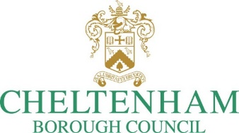

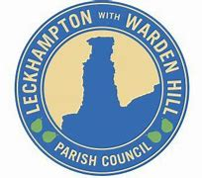

Leckhampton with Warden Hill

Parish Council

Regulation-16 Public Consultation

**Consultation Closing Date: 23:59 on 30 May 2025**

[**cheltenham.gov.uk/consultations**](https://www.cheltenham.gov.uk/consultations)

## Overview

Thank you for your interest in the future of Leckhampton and Warden Hill area.

Leckhampton with Warden Hill Parish Council has drafted a Neighbourhood Plan which went through a Regulation-16 consultation last year, and as a result proposed amendments have been made to the plan. In light of this, Cheltenham Borough Council as the Local Planning Authority, has publicised an additional Regulation-16 consultation on the proposed amendments for a minimum 6-week period in accordance with the Neighbourhood Planning Regulations 2012 (as amended). This consultation will allow residents in the area, local businesses and interested parties to comment on the proposed amendments.   
  
At its forefront this Neighbourhood Plan contains planning policies and proposals for improving the area. It will deal with a wide range of social, economic and environmental issues from local commercial and community facilities, from the transport links, cycle lanes and walking routes, to local heritage, improvements to local flood risk and the protection of open space, including designated Local Green Space on the Leckhampton Fields. All documents related to the plan can be downloaded by clicking the link below:  
  
[cheltenham.gov.uk/downloads/download/2046/draft_leckhampton_with_warden_hill_neighbourhood_plan](https://www.cheltenham.gov.uk/downloads/download/2046/draft_leckhampton_with_warden_hill_neighbourhood_plan)   
  
Evidence and further documentation have been added as appendices and annexes, like social and demographic profile of the area, lists of heritage buildings and green spaces. A travel and transport plan and statements including important background information on the areas valued landscape can also be viewed.If agreed, the Neighbourhood Plan will be an important influence on guiding future development in Leckhampton and Warden Hill. It sets out the Parish Council’s vision for the area and the policies they would like to see followed by decision-makers, especially when it comes to planning applications.  
  
This consultation will run for just over **6 weeks** from **14th April 2025**until **11:59pm on** **30th May 2025**.   
  
For details of how your information will be used please see Cheltenham Borough Council's privacy policy: [cheltenham.gov.uk/your-data](https://www.cheltenham.gov.uk/your-data)

## Introduction

What is your name?

What is your email address?

What describes your interest in this consultation?

|  |  |
| --- | --- |
|  | Local land/property owner |
|  | Local business |
|  | Local resident |
|  | Local authority/Parish Council |
|  | Planning/other consultant |
|  | Developer |
|  | County/District Councillor |
|  | Private organisation |
|  | Other organisation |

What is your organisation?

## Tell us what you think

What section of the Plan do you wish to comment on?

Please write your comment below

**If you would like to provide a further comment, please print this page again**

## What next?

At the end of the consultation, the Neighbourhood Plan will be submitted to an Independent Examiner for consideration and their report will determine if the Plan can go forward to a Referendum, which local residents will get the opportunity to vote on.

Comments received will be collated and sent to the Independent Examiner, together with all comments that were previously submitted in last year’s Regulation-16 consultation. This means that they will only be considered within the remit of the Independent Examination (i.e. whether the Neighbourhood Plan proposal meets the set of conditions as set out by law).