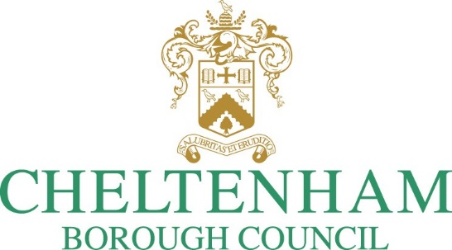

Consultation on the statutory Licensing Act 2003 Statement of Licensing Policy review

**Consultation Closing Date: 23:59 on 7 September 2025**

[**https://www.cheltenham.gov.uk/consultations**](https://www.cheltenham.gov.uk/consultations)

Contents

Introduction 3

How you can respond 3

Privacy and Data Protection 3

Policy Proposals 4

Consultation 14

# Introduction

Cheltenham Borough Council (the authority) previously adopted its [Statement of Licensing Policy](https://www.cheltenham.gov.uk/downloads/file/442/licensing_policy_statement) in 2021. The main purpose of this policy is to provide clarity to applicants, responsible authorities, elected Members and other persons on how the authority will determine applications for the sale/supply of alcohol, the provision of regulated entertainment and the provision of late-night refreshment and also to provide a basis for all licensing decisions taken by the authority over the next five years. It will also inform elected Members of the parameters within which licensing decisions can be made.

There is a statutory requirement to review the document at least every 5 years.

The proposed amendments are shown in this form for any consultee to complete. Changes are also shown in tracked changes in the draft policy document.

# How you can respond

This consultation **closes at 23:59 on 7 September 2025 (6 weeks).** There are several ways to respond to this consultation:

* [Online using the electronic consultation form](https://forms.office.com/Pages/ResponsePage.aspx?id=-YeOie3om0SvpBNTRu0yS-8PnDIy3MlMtPbKXQ0khpFUMjhLOEdIOFg4U0FTR1ZOSkg5TVM0N0pUVi4u)
* By completing and returning this form to [licensing@cheltenham.gov.uk](mailto:licensing@cheltenham.gov.uk) or by post to:

Cheltenham Borough Council

Licensing Section

Municipal Offices

Promenade

Cheltenham

GL50 9SA

# Privacy and Data Protection

The Licensing Consultations Privacy Statement can be found on the authority’s website at <https://www.cheltenham.gov.uk/info/81/how_we_use_your_data/1375/licensing_privacy_data>.

# Policy Proposals

This section of the consultation document **outlines the proposed policy changes and amendments that the authority is specifically seeking feedback on** as part of the consultation process.

|  |
| --- |
| **About You**  Name (optional): _______________________________________  Email address:  Which best describes the capacity in which you are responding to this consultation (**required**):  🞏 A councillor/committee member  🞏 A Member of Parliament  🞏 A licence holder  🞏 A customer of the licensed trade  🞏 A statutory body (police etc.)  🞏 A body (for example disability awareness group)  🞏 Other not specified (please specify): _______________________________________ |

1. Addition of information regarding personal licences.

|  |
| --- |
| **Question: Do you agree with the additional information regarding personal licences? (required)**  🞏 Yes  🞏 No  Please provide any further comments you wish to make in relation to your answer. (**optional**) |

1. Inclusion of a section covering woman’s safety and wider vulnerability.

|  |
| --- |
| **Question: Do you agree with the inclusion of woman’s safety and wider vulnerability? (required)**  🞏 Yes  🞏 No  Please provide any further comments you wish to make in relation to your answer. (**optional**) |

1. Inclusion of advice around suspension of premises licences and club premises certificates for non-payment of annual fees.

|  |
| --- |
| **Question: Do you agree with the additional information regarding annual fee suspensions? (required)**  🞏 Yes  🞏 No  Please provide any further comments you wish to make in relation to your answer. (**optional**) |

1. Do you have any further comments regarding the Statement of Licensing Policy?

|  |
| --- |
| 🞏 Yes  🞏 No  Please provide any further comments you wish to make in relation to your answer. (**optional**) |

# Consultation

The authority is keen to hear your views on these proposals, and is consulting with the trades it regulates, relevant stakeholders and the wider public.

We will also use the authority website to publicise the consultation taking place and our proposals. An online survey tool to respond to the consultation is available on our website and in paper form available from the authority reception area at the Municipal Offices.

We will also consult directly with the following groups, organisations or individuals.

* Responsible Authorities as prescribed by the Licensing Act 2003
* The Cheltenham Borough Authority – Licensing Committee
* The local MP
* Cheltenham Borough Council elected members
* Cheltenham Business and Improvement District (BID)
* Cheltenham Borough Council Marketing and Events team
* Cheltenham Safe
* Holly Gazzard Trust
* Disability groups

If you have any questions about this consultation, please contact [licensing@cheltenham.gov.uk](mailto:licensing@cheltenham.gov.uk).

before making the final decision in respect of these proposals.