Inspiring young people through twinning

Expression of interest form

About you
Name of Contact Person
Address
Telephone
Email
Name of organisation (s) submitting the form
Your relationship to the organisation (s)

About the organisation (s) submitting the proposal

Please describe the status of the organisation (s) submitting the form. If you are submitting the proposal as part of a consortium we will need to know with whom the council will legally contract with and then how the consortium will be managed in terms of project delivery and financial accountability.

Registered charity |  | Charity number:
Company Limited by guarantee |  | Company number:
Charitable Trust |  | Constituted Voluntary organisation
Public sector

Other (please explain)
If you are a charity with an income over £5,000, have you registered with the Charity Commission? YES / NO If not, we may contact you about this.

Is your organisation signed up to the Gloucestershire Compact? If not, are you willing to consider it? YES / NO
About your project

Name of project

Which of our twin and friendship towns are you interested in working with?

Please give a brief description of what you would like to do.

Please supply information about how your project could deliver the 8 outcomes areas
- Young people enjoy positive experiences that stimulate their interest in international languages and cultures.
- Young people enjoy positive experiences that help them with their current education and help them make the right choices about future education options.
- Young people enjoy positive experiences that help them become more employable.
- Young people enjoy sporting opportunities.
- Young people are more aware of the relationships between Cheltenham and our twin towns.
- Young people gain valuable insights into the culture of our twin-towns and their countries
- Young people improve their language skills.
- Young people’s work experience so getting them ready for work.

How will you engage with young people in the design of the project?

How will you gain evidence that there is a need for the project?

How will you ensure that young people can easily access the project?

How will you manage the project?

How will you manage the project in relation to safeguarding?

What plans have you got for contacting host organisations in our twin and friendship towns?

About the money you are asking for
 | £
How much do you think your project will cost in total?
How much will you be asking the council for?
Where will the rest of the funding come from?
Please itemise each source
SOURCE | £ | Is this funding secured?
 |  | YES / NO
 |  | YES / NO

How you will spend the money
Please supply estimates of what you plan to spend the money on | Total spend | Grant requested
Staff expenses

Other staffing related expenses

Equipment or materials

Event costs

Management Costs

Other

TOTALS

This part is to be signed by all applicants.

If you are submitting this form by email, please print and send a signed copy (at least a copy of your signature page) in the post to the address at the bottom of this form.

Declaration and Data Protection Statement Data Protection Act 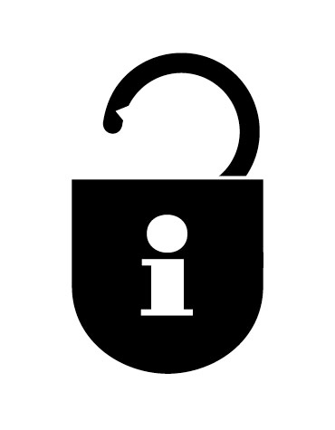

I confirm that the organisation/group named in this form has authorised me to sign this application on their behalf.

The information contained in this application is correct, to the best of my knowledge, and I confirm that any grant aid received will be used solely for the purposes specified in the application.

I agree to my name and my organisation’s details being held on paper or electronic files.

I understand that the information in this form may be shared with other local funders.

Signature
Name of person signing
Position in Organisation
Date

For further information, please contact
Annette Wight, Twinning Officer, Cheltenham Borough Council, Municipal Offices, Promenade, Cheltenham, GL50 1PP

Tel : 01242 264311

Annette.wight@cheltenham.gov.uk

The closing date is 5.00pm Friday 13 January 2012. Decisions will be made by the Twinning Association on Tuesday 17January 2012.

