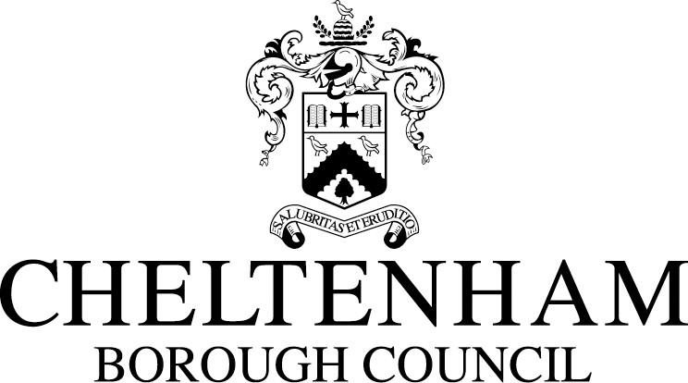

Budget Consultation 2012/13

Your views matter – have your say…

Cheltenham Borough Council wants to hear your views on how you think the Cabinet should shape the final budget proposals for 2012/13.

Please complete this form either by hand or on your computer and return it to the Council at the address shown below by 13th January 2012.

Budget Consultation
Financial Services
Cheltenham Borough Council
Municipal Offices
Promenade
Cheltenham
GL50 1PP
Or email: moneymatters@cheltenham.gov.uk

This form is also available online at www.cheltenham.gov.uk

Q1 Given the need to find savings of £1.15m in 2012/13, do you think the council has compiled a list of proposals which is broadly acceptable given the circumstances?

Yes
No

Q2 Are there any proposals for cuts which you do not support?

Q3 If you have answered No to Question 1, what savings could be made instead of the proposals you do not support?

Q4 Given the need to make further savings in future in response to more reductions in government funding where should the council continue to look to make savings? Please identify any services where you believe the council should reduce, or stop funding.

Q5 Finally, do you have any general comments on the proposed budget?

Thank you for taking the time to give us your views on the proposed 2012/13 budget. Your views will be taken into account by councillors when they decide on the final budget.

To find out more, visit the Council’s website at www.cheltenham.gov.uk

