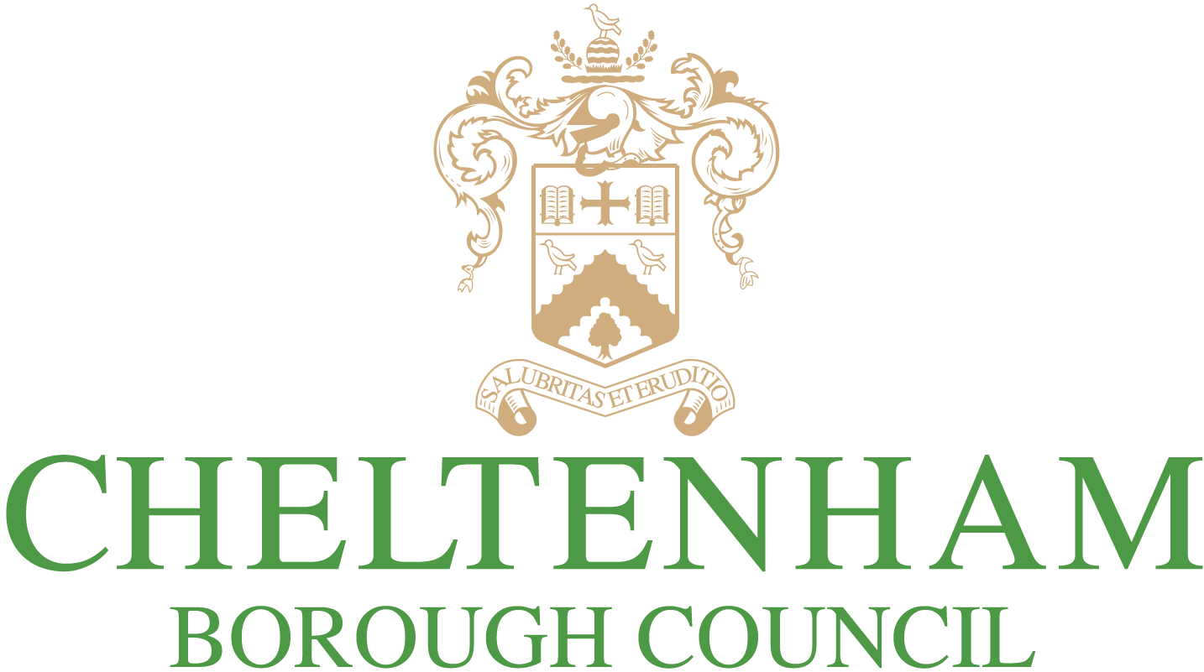

Cheltenham Plan Scoping Consultation

Work has begun on the new Cheltenham Plan and we want to hear your views on what the plan should contain. Before completing this feedback form we suggest you read the Cheltenham Plan Scoping Document.
Contact details:
Please provide your name and contact details (or details of the client you represent) below. We cannot accept anonymous responses. You must, as a minimum, provide a name or organisation AND an address or email.
Agent Details:
If you are acting on behalf of another person or organisation, please provide your details here.
Title (Mr,Mrs,Ms,Miss,Other)
Name
Organisation (if relevant)
Job Title (if relevant)
Address

Postcode
Telephone
Email
Title (Mr,Mrs,Ms,Miss,Other)
Name
Organisation (if relevant)
Job Title (if relevant)
Address

Postcode
Telephone
Email

1. Do you have any comments on the timetabling for producing the Cheltenham Plan?
Please see Process & Timetable section within Scoping Document

2. Do you have any comments on the current corporate vision and JCS vision and how they should relate to Cheltenham?
Please see Vision & Objectives section within Scoping Document

3. Please tell us your vision for Cheltenham

4. What do you think about the idea of a themed vision?

5. Name one thing in Cheltenham that you like

6. Name one thing in Cheltenham you think needs to change

 | No View | Not Very Important | Quite Important | Very Important
To achieve a high standard of design in new development
To reduce crime and the fear of crime
To make provision for identified development needs
To create more sustainable patterns of development, with priority use of previously-developed land
To meet the needs of the elderly and people with disabilities
To conserve and improve Cheltenham’s architectural townscape and historical heritage
To conserve and improve Cheltenham’s landscape character and green environment
To prevent coalescence of Cheltenham with other settlements
To reduce waste and energy consumption and conserve natural resources
To maintain and enhance the economic vitality of the borough
To safeguard land and buildings in existing employment use, or if unoccupied, last in employment use
To meet housing requirements, including the need for affordable housing
To maintain and enhance the vitality and viability of the town centre as a sub-regional shopping centre
To increase the range of facilities for recreation and leisure
To encourage provision of a range of facilities and attractions for tourists
To encourage the retention and provision of a range of community facilities and services
To promote sustainable transport
To ensure infrastructure in development is provided to a satisfactory standard
7. Below is a list of objectives compiled from the existing Local Plan. Please indicate how important you think each of these objectives is (please cross one box for each objective):
Further details are within the Vision & Objectives section within Scoping Document

8. Are there any other objectives that you would suggest?

9. How can we make the objectives more specific to Cheltenham?

The Scoping Document includes a list of policy areas that we think the Cheltenham Plan needs to cover
Please see Potential Policy Areas within the Scoping Document for full list

10. Do you think we have missed anything?

11. Do you have any suggestions, specific to Cheltenham, for how we should develop these policy areas?

It is Important that the objectives and policies of the plan can be delivered, in other words actually provided, protected or built.

12. What do you think are the key considerations in ensuring that our plan is deliverable?

COMMENTS:
13. If you have any further comments, please write them below:

14. How did you hear about the Cheltenham Plan Scoping Consultation?

- Website
- Email
- Social media
- Advertising/display
- Library
- Word of mouth
- Database contact
- Other:
Thank you for submitting your response for the Cheltenham Plan Scoping Consultation
To keep up to date with the Cheltenham Plan, please visit www.cheltenham.gov.uk/localplan

