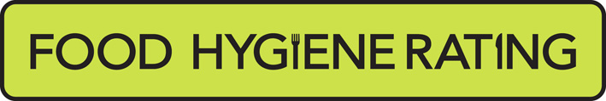  Food Hygiene Rating Scheme:  Appeal form | 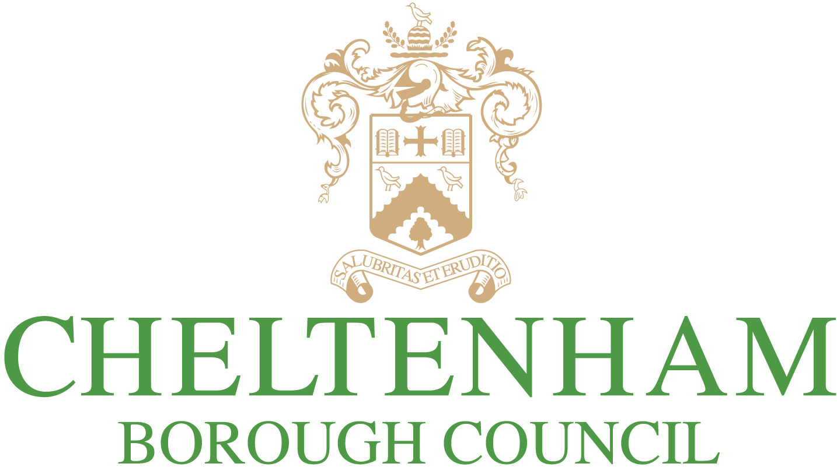 | 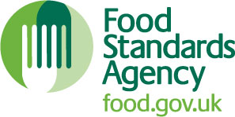

Notes for businesses:

- As the food business operator of the establishment you have a right to appeal the food hygiene rating given following your inspection if you do not agree that the rating reflects the hygiene standards and management controls found at the time of the inspection.
- You have 21 days (including weekends and bank holidays) from the date of receipt of the notification letter to lodge an appeal.
- Please use the form below and address it to the Lead Officer for Food at Cheltenham Borough Council. You can return your form using the details shown below.
- Your rating will be reviewed and the outcome of your appeal communicated to you within 21 days.

Business details
Food business operator/proprietor

Business name

Business addresses

Business tel. number |  | Business email

Inspection details
Date of inspection |  |  |  |  | Food hygiene rating given
Date notified of rating

Appeal
I do not agree with the food hygiene rating given by the food safety officer because (please explain below under each of the three headings).

Compliance with food hygiene and safety procedures

Compliance with structural requirements

Confidence in management/control procedures

Signature
Name in capitals

Position |  | Date

Please return this completed form by email to envhealth@cheltenham.gov.uk or by post to:
Environmental Health, Cheltenham Borough Council, Municipal Offices, Promenade, Cheltenham, GL50 9SA

This authority is obligated to process information fairly and lawfully. The council will process the information you have provided accordance with the relevant privacy statement available at www.cheltenham.gov.uk/your-data.

