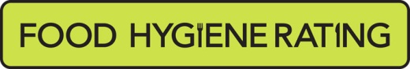  Food Hygiene Rating Scheme:  Request for a re-visit | 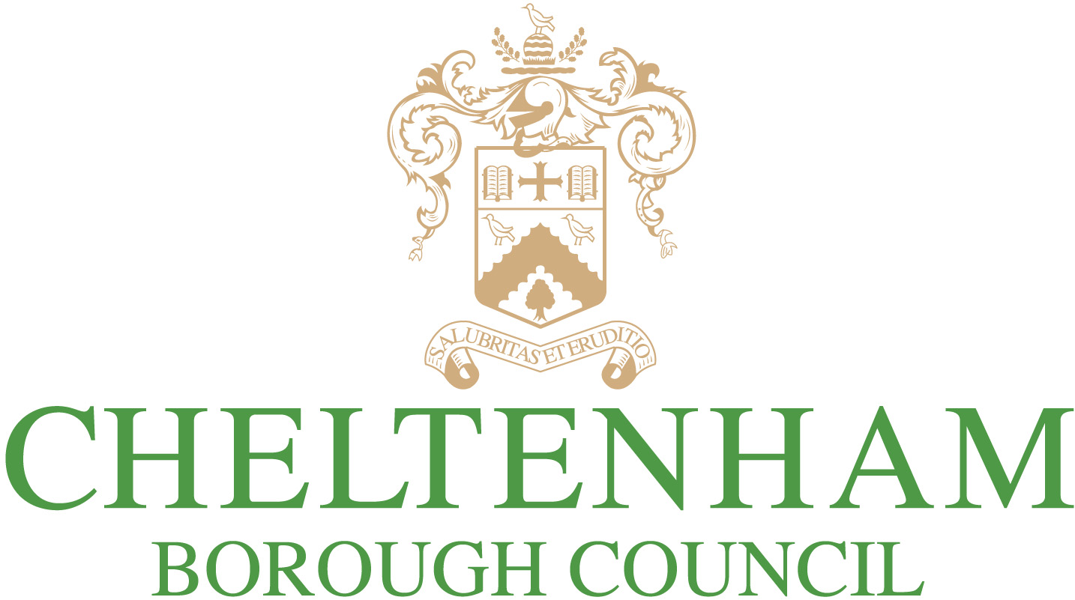 | 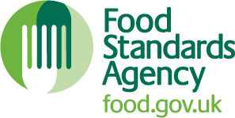

Notes for businesses:

- As the food business operator of the establishment you have a right to request a re-visit for the purposes of re-rating if you have taken action to rectify the non-compliances identified at the time of inspection.
- We make a charge for this service of £185.00. The unannounced re-visit will normally be carried out within 3 months from the date the request is approved. Details of how to pay will be provided if your request is successful. There is no limit on the number of requests you may make, but the fee will apply for each valid request.
- You can make your request at any time after the statutory inspection provided that you have made the required improvements.
- You must provide details of the improvements made with your request, including supporting evidence where appropriate. If we consider that you have provided sufficient evidence that the required improvements have been made, an unannounced, full inspection will take place.
- We will give you a ‘new’ food hygiene rating based on the level of compliance that is found at the time of the re-visit - you should be aware that your rating could go up, down or remain the same.
To make a request for a revisit, please complete this form below and return it to the address below, with your payment.

Business details
Food business operator/proprietor

Business name

Business addresses

Business tel. number |  | Business email

Inspection details
Date of inspection |  |  |  |  | Food hygiene rating given

Action taken
Please describe the remedial action you have taken with reference to the issues identified in the inspection letter/report provided to you by your local authority with your score:
Compliance with food hygiene and safety procedures

Compliance with structural requirements

Confidence in management/control procedures

Please provide any other supplementary evidence (e.g. photographs, invoices, copies of relevant HACCP documentation etc.).

Signature
Name in capitals

Position |  | Date

Please return this completed form by email to envhealth@cheltenham.gov.uk or by post to:
Environmental Health, Cheltenham Borough Council, Municipal Offices, Promenade, Cheltenham, GL50 9SA

This authority is obligated to process information fairly and lawfully. The council will process the information you have provided accordance with the relevant privacy statement available at www.cheltenham.gov.uk/your-data.

