Request for a re-inspection  Animals Activity Star Rating System | 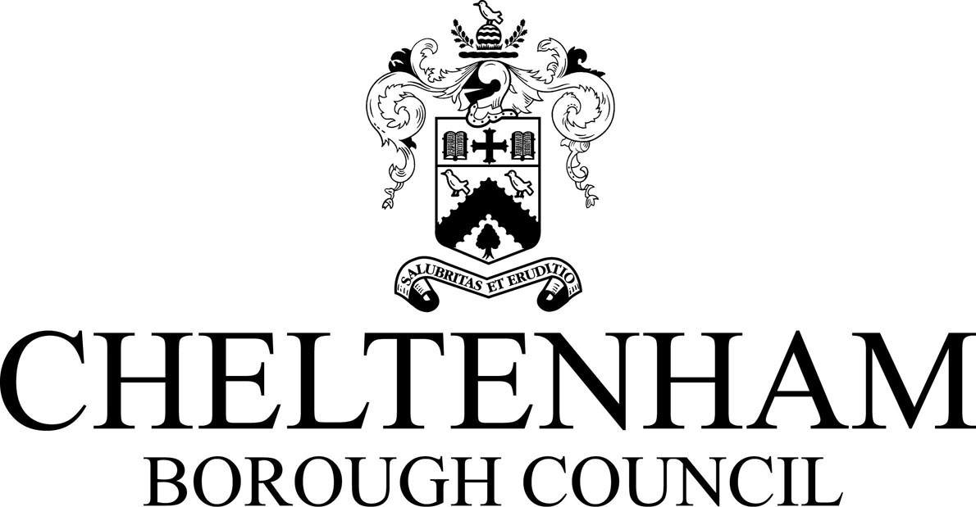

Notes for businesses:

- If you accept the star rating given and have made the necessary improvements to address the non-compliances identified, you have a right to request a re-inspection for the purposes of re-rating.
- A re-inspection request can be made on this form at any time after receipt of the full inspection report and before the renewal date.
- The fee for this service is found on our website www.cheltenham.gov.uk/animal-licencing and must be paid after officer approval for the application.
- A re-visit will be carried out within three months from the date of an approved re-inspection application.
- Some visits will be announced; however your request for a re-inspection presumes permission for an unannounced visit where appropriate (i.e. for cleanliness standards).
- A full-inspection will be undertaken (where applicable). Following which we will give you a star rating based on what is found at the time of the re-visit. You should be aware ratings could go up, down or remain the same.
- Ensure all sections of this form are completed and returned to the address below. Use additional sheets where necessary.

Business details
Licence Number:
Name of business operator/proprietor

Business name

Premises addresses

Contact number |  | Contact email

Inspection details
Last Inspection Date |  |  |  |  | Current star rating

Action taken
Please describe the remedial action you have taken with reference to issues identified in the last inspection letter/report. Use additional sheets if necessary:
List any supplementary evidence included (e.g. photographs, invoices, copies of relevant documentation etc.).

Signature
Name in capitals

Position |  | Date

Please return via email to animal.licensing@cheltenham.gov.uk or by post to Environmental Health, Cheltenham Borough Council, Municipal Offices, Promenade, Cheltenham GL50 9SA

This authority is obligated to process information fairly and lawfully. The council will process the information you have provided accordance with the relevant privacy statement available at www.cheltenham.gov.uk/your-data.

