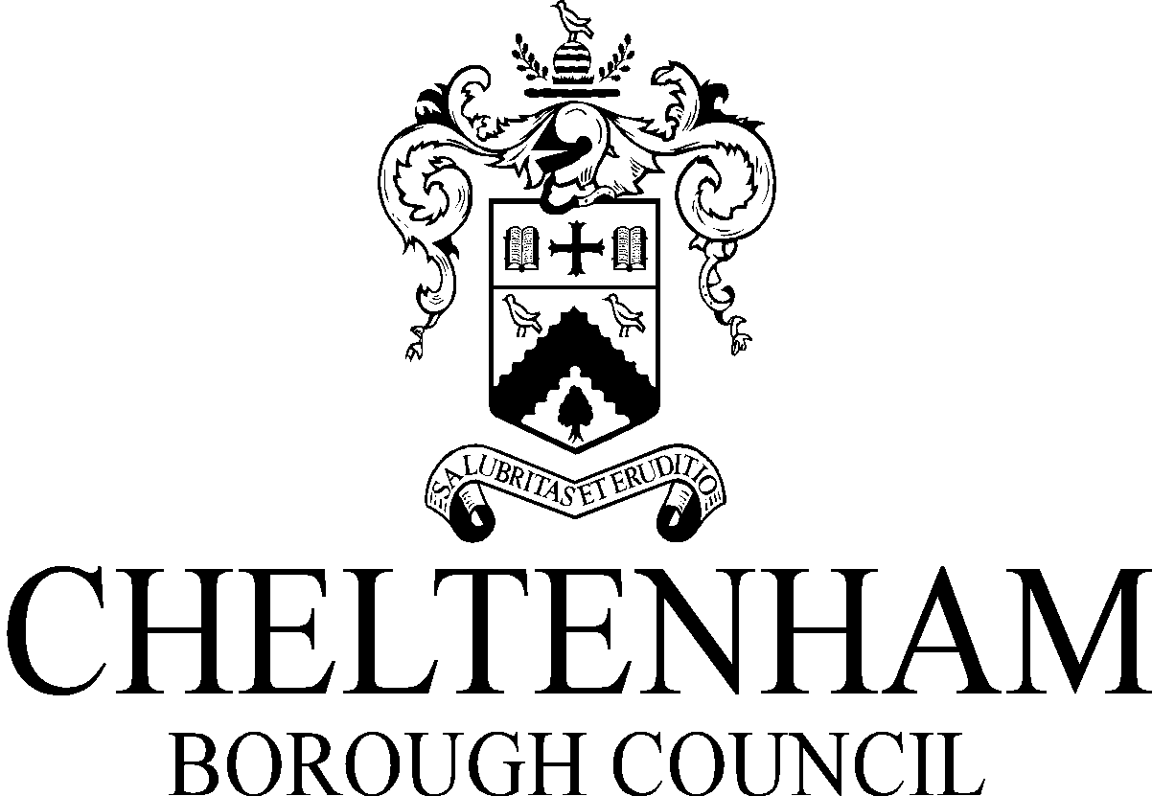
Please read the notes overleaf before completing the form and declaration below. Email the completed form to businessrates@cheltenham.gov.uk
If you require assistance please contact the Business Rates team on 01242 264255
Retail Discount 2021/22 Application Form
Only for use by businesses verifying they continue to qualify from 1 July 2021
Business Rates Account Reference

Business name (business name as stated
on Business Rates bill)
Address of property discount is being
applied in respect of
Was your business legally required to
close from 5th January 2021?
Has your business received or applied for
the expanded retail discount for any
other properties in England?
Will claiming the expanded retail discount
on the above property result in either cash
cap being exceeded ?

Declaration:
I confirm that the business will not exceed the applicable cash cap as a result of the expanded retail discount being awarded on the above property.
The Government and Cheltenham Borough Council will not tolerate any business falsifying their records or providing false evidence to gain this discount, including claiming support above the cash cap. A ratepayer who falsely applies for any relief, or provides false information or makes false representation in order to gain relief may be guilty of fraud under the Fraud Act 2006.
Name of person submitting form:
Position in company:
Email address:
Contact Number:
Date:

Expanded Retail Discount 2021/22
To be eligible for this discount, the retail premises must:
- be occupied
- be wholly or mainly used as shops, restaurants, cafes, drinking establishments, cinema, live music venues, hotels, guest and boarding premises, self-catering accommodation, sport and leisure facilities, tourist attractions, community halls and clubhouses used by for assembly and leisure by visiting members of the public.
How the Cash Caps work

The cash cap applies to the 66% discount from 1 July 2021.

For businesses required to close by law from 5 January 2021 the cap is set at £2 million worth of the discount. The £2million cap is for all premises the business occupies and is eligible for relief in England.

For business ratepayers allowed to open from 5 January 2021 the cap is set at £105,000. The £105,000 cap is for all premises the business occupies and is eligible for relief in England. This cap applies to businesses that were allowed to open but chose to close.

No business ratepayer in any circumstances can receive more than £2 million. Where a ratepayer eligible for the closed business cash cap also occupies premises that were able to open and the value of the discount on the closed premises is less than £2 million then they may also claim the discount on the open premises, but only up to the cap of £105,000.

Read the full guidance provided by the Government

