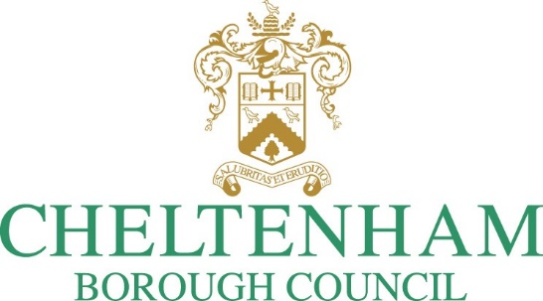

Licensed Vehicle Emission and Wheelchair Accessibility Policy

Version Control
1 | Draft for consultation

Introduction
Cheltenham Borough Council (“authority”) has declared a 'Climate Emergency' and committed to become a net zero carbon council and borough by 2030. In September 2021, the Cabinet Member Customer & Regulatory Services announced the authority’s ambition to transition it licensed Hackney Carriage fleet to a fully carbon neutral fleet.
In addition, the authority’s draft Air Quality Action Plan sets out a number of actions, specifically relating to licensed vehicles, that seeks to implement a range of measures to improve emissions from licensed vehicles.
This policy implements these plans and strategies.

Scope & Implementation
This policy applies to Hackney Carriage and Private Hire vehicles licensed by the authority.
The substantive policy document sets out how and when the various measures will be implemented.
Any further questions can be directed to licensing@cheltenham.gov.uk.

Policy Overview
This policy implements the ambition of the authority to operate a fully net zero carbon fleet by 2030. The stated approach by the authority is to implement these requirements in stages focussing on phasing out the most polluting vehicles as a first step.
This policy preserves the authority’s commitment to maintain a high level of accessibility. To this end, unless exceptional circumstances apply as outlined in this policy, the requirement for new and replacement vehicles to be fully wheelchair accessible remains unchanged.
This overview provides a quick reference and easy read guide for licence holders. The detail of this policy can be found set out further down this document.

Staged Implementation

Hackney Carriage Vehicles
The authority will implement its fully net zero carbon fleet in accordance with the table below:
Euro Emission Standards | Replacement Date | Replacement Requirement
Licensed vehicles manufactured to Euro 3 or 4 Standards | Must be replaced on 2023 renewal date | Must be replaced with:  - silver WAV manufactured to Euro 6;  - carbon neutral WAV; or  - Euro 6 plug-in hybrid WAV.
 |  | Euro 6 WAV/ plug-in hybrid replacement (above) to be replaced with carbon neutral WAV on renewal 2028.
Non-wheelchair accessible vehicles manufactured to Euro 5 or 6 standards | Must be replaced on 2026 renewal date in accordance with the requirements set out in paragraph 1.5 | By the dates specified, licensed vehicles manufactured to Euro 5 emission standards must be replaced with fully carbon neutral wheelchair accessible vehicles
Non-wheelchair accessible vehicles manufactured to Euro 6 standards | Must be replaced on 2027 renewal date in accordance with the requirements set out in paragraph 1.5 | By the dates specified, licensed vehicles manufactured to Euro 6 emission standards must be replaced with fully carbon neutral wheelchair accessible vehicles
Wheelchair accessible vehicles manufactured to Euro 5 or 6 standards | Will continue to be licensed in accordance with circumstances prior to mandatory WAV policy cancellation. | - WAVs adapted 10 years from the date first licensed but with a maximum permitted licensing period of 2030; or  - Purpose built WAVs 14 years from the date first licensed but with a maximum permitted licensing period of 2030.  Wheelchair accessible vehicles can only be replaced with another wheelchair accessible vehicle.

Private Hire Vehicles
Euro Emission Standards | Licence date | Replacement Requirement
Licensed vehicles manufactured to Euro 3 and 4 standards | Must be replaced on 2023 renewal date | - A petrol vehicle manufactured to at least Euro 6 Emission Standards;  - A Euro 6 plug-in hybrid; or  - A fully carbon neutral vehicle
 |  | Euro 6 WAV/ plug-in hybrid replacement (above) to be replaced with fully carbon neutral WAV on renewal 2028.
Licensed vehicles manufactured to Euro 5 Standards | Must be replaced on 2025 renewal date | - A petrol vehicle manufactured to at least Euro 6 Emission Standards;  - A Euro 6 plug-in hybrid; or  - A fully carbon neutral vehicle

Overview Chart
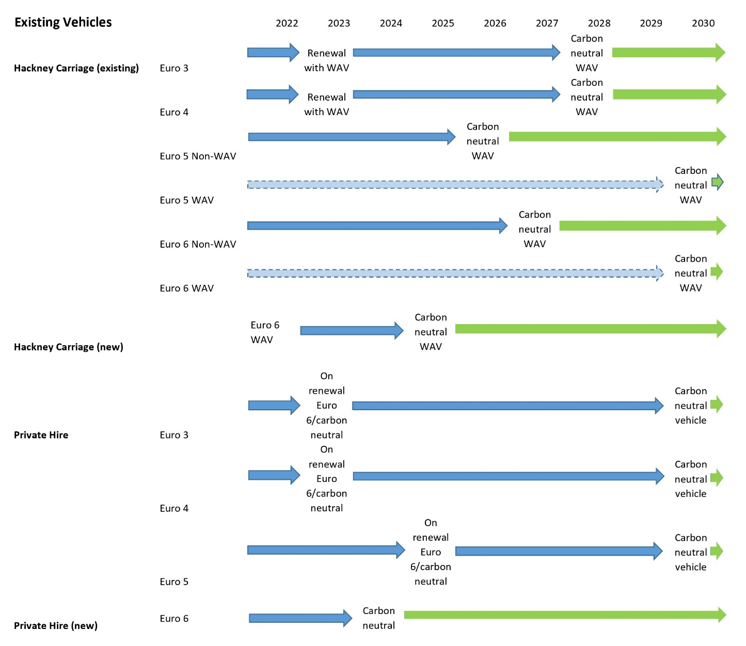

Hackney Carriage Vehicles

Existing Licensed Vehicles

  - The general approach adopted by the authority to facilitate the transition from fossil fuel vehicles to a fully carbon neutral and accessible fleet, is to gradually implement higher emission standards.
  - In line with this general approach, the oldest and most polluting fossil fuel vehicles will be phased out as an immediate first step:
Euro Emission Standards | Licence date
Licensed vehicles manufactured to Euro 3 Standards | Must be replaced on 2023 renewal date
Licensed vehicles manufactured to Euro 4 Standards | Must be replaced on 2023 renewal date
Table 1

  - Subject to 1.6 and 1.7, licensed vehicles manufactured to Euro 3 and Euro 4 standards must be replaced with either:
    - Silver WAV manufactured to Euro 6;
    - Fully carbon neutral WAV;
    - Euro 6 plug-in hybrid WAV.
  - Euro 6 WAV/ plug-in hybrid replacement (above) to be replaced with fully carbon neutral WAV on renewal 2028.
  - Other vehicles will continue to be licensed in accordance with the table below:
Euro Emission Standards | Licence date
Non-wheelchair accessible vehicles manufactured to Euro 5 Standards | Must be replaced on 2026 renewal date in accordance with the requirements set out in paragraph 1.6
Wheelchair accessible vehicles manufactured to Euro 5 Standards | Will continue to be licensed in accordance with paragraph 1.7.
Vehicles manufactured to Euro 6 Standards | Must be replaced on 2027 renewal date in accordance with the requirements set out in paragraph 1.6
Wheelchair accessible vehicles manufactured to Euro 6 Standards | Will continue to be licensed in accordance with paragraph 1.7.
Table 2

  - Licensed vehicles manufactured to Euro 5 or Euro 6 emission standards must be replaced with fully carbon neutral wheelchair accessible vehicle.
  - Recognising that some vehicle proprietors have already converted to WAVs under the previous policy, the authority will honour the maximum vehicle age limits under which they were licensed but subject to a maximum period to 2030 to coincide with the authority’s carbon neutral commitment:
    - WAVs adapted 10 years from the date first licensed but with a maximum permitted licensing period of 2030; or
    - Purpose built WAVs 14 years from the date first licensed but with a maximum permitted licensing period of 2030.

Replacement Vehicles
  - Wheelchair accessible vehicles can only be replaced with another wheelchair accessible vehicle.
  - Unless exceptional circumstances apply, non-wheelchair accessible vehicles must be replaced with:
    - silver WAV manufactured to Euro 6;
    - fully carbon neutral WAV; or
    - Euro 6 plug-in hybrid WAV.

Exceptional Circumstances
  - The authority will, on a case-to-case basis, allow existing vehicle licence holders to, in exceptional circumstances, replace their vehicle on a “like for like” basis. Exceptional circumstances would relate to an acute situation where an existing licensed vehicle either:
    - sustains significant damage that renders the vehicle unroadworthy; and/or
    - suffers acute and substantial mechanical failure

but where the licensed vehicles would otherwise have been considered fit for licensing had the damage or mechanical failure not occurred.

  - Note that exceptional circumstances will not apply in cases where a licensed vehicle comes to a natural end of its fitness due to, for example, natural wear and tear, age of the vehicle or inability to pass statutory or other fitness assessments.

Maximum Age Limits

Carbon neutral Wheelchair Accessible Vehicles
  - The authority does not impose a maximum age limit for licensed carbon neutral wheelchair accessible vehicles provided the licensed vehicle continues to comply with the authority’s fitness standards for licensed vehicles.

New Vehicles
  - The policy requirement that all new Hackney Carriage vehicles must be fully wheelchair accessible is preserved in this policy.
  - The authority will impose an additional requirement that from 1 January 2025, any new Hackney Carriage vehicles to be licensed must be fully carbon neutral wheelchair accessible vehicles.

Private Hire Vehicles

Existing Licensed Vehicles

2.1 The authority does not currently have plans to implement a mandatory carbon neutral vehicle policy for licensed private hire vehicles.
2.2 To mitigate the environmental impact of the licensed private hire fleet however, this policy aim is to improve the environmental impact by ensuring that older and more polluting vehicles are gradually phased out and replaced by less polluting fossil fuel vehicles.
2.3 To this end, the authority will impose the following licensing requirements:
Euro Emission Standards | Licence date
Licensed vehicles manufactured to Euro 3 Standards | Must be replaced on 2023 renewal date.
Licensed vehicles manufactured to Euro 4 Standards | Must be replaced on 2023 renewal date
Licensed vehicles manufactured to Euro 5 Standards | Must be replaced on 2025 renewal date
Table 3
  - Licensed private hire vehicles must be replaced with either:
    - A petrol vehicle manufactured to at least Euro 6 Emission Standards;
    - A Euro 6 plug-in hybrid; or
    - A fully carbon neutral vehicle.

Maximum Age Limits
  - Subject to table 3 and 2.6, licensed private hire vehicles will be licensed for a maximum period of 8 years provided the licensed vehicle continues to comply with the authority’s fitness standards for licensed vehicles.
  - The authority does not impose a maximum age limit for licensed carbon neutral vehicles provided the licensed vehicle continues to comply with the authority’s fitness standards for licensed vehicles.

New vehicles
  - 1 January 2024, all new private hire vehicles must be either:
    - A petrol vehicle manufactured to at least Euro 6 Emission Standards; or
    - A hybrid vehicle; or
    - A fully carbon neutral vehicle.

